**Homework 5 Solution**

1. Find an example of numbers *a, b* and *n* such that $2a≡2b (mod n)$ but $a≠b (mod n).$

If we think about the definition of equivalence, we want an example of numbers so that *n* does not divide $a-b$ but divides $2a-2b.$ Say, $2(a-b)=2a-2b=k⋅n.$ Divide both sides by 2, we get $a-b=k⋅n/2.$ If we cannot factor out *n* from the right hand side (because $a-b$ is not divisible by *n*), that means 2 divides *n* but not *k,* so $n=2m$ and *k* is odd. If we choose both $a, b$ to be from the least complete residue system, we then have $k=1.$ So given $n=2m$ for some *m* and for any *b*, if we let $a=b+m,$ the statement will be satisfied.

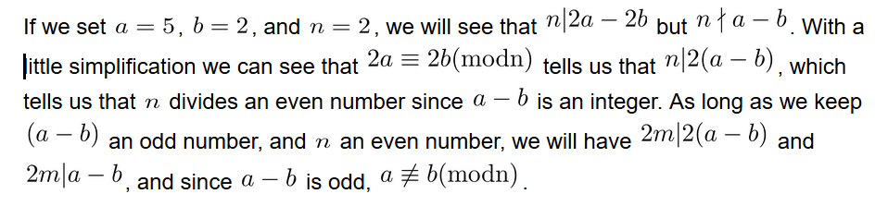

1. Suppose that $n={n_{1}n}_{2}$ where $gcd(n_{1}, n_{2})=1.$ Show that $a≡b (mod n)$ if and only if $a≡b (mod n_{1})$ and $a≡b (mod n_{2}).$

* If $a≡b (mod n)$ then $a≡b (mod n_{1})$ and $a≡b (mod n_{2}).$
  + $n | a-b$ by the definition of congruence.
  + Since $n_{1}n_{2} | a-b$ then $n_{1} | a-b$ and $n_{2} | a-b$.
  + Thus, by the definition of congruence, $a≡b (mod n_{1})$ and $a≡b (mod n_{2})$.
* If $a≡b (mod n_{1})$ and $a≡b (mod n_{2})$ then $a≡b (mod n)$.
  + $n_{1} | a-b$ and $n_{2} | a-b$ by the definition of congruence. So $a-b=k_{1}n_{1}$ and $a-b=k_{2}n_{2}$.
  + Thus, $a-b$ is a common multiple of $n_{1}$ and $n_{2}$ and so $lcm(n_{1}, n_{2}) | a-b$.
  + Since $gcd(n_{1}, n_{2})=1$ and we know that $gcd(n_{1}, n_{2})⋅lcm(n_{1}, n_{2})=n_{1}n_{2}$ then $lcm(n_{1}, n_{2}) = n_{1}n_{2}=n$.
  + So $n | a-b$ and $a≡b (mod n)$ by the definition of congruence.

Assume $a≡b (mod n).$ By definition n|(a-b), so there exists some integer k such that a-b = k*n. Using the fact that n = n_1*n_2 we will show—without loss of generality—that n_1 divides a-b.

a-b = k*n_1*n_2 = n_1(kn_2).

So, by definition n_1 divides a-b and n_2 divides a-b.

We will now show that the reverse direction is true. That is, we assume a ≡ b (mod n_1) and a≡ b (mod n_2) and we will show that a≡b (mod n).

We know that gcds(n_1,n_2) = 1, which means that there exist integers x, y such that

n_1x + n_2y = 1.

Using this fact, and multiplying both sides of the equation by (a-b) we see that

n_1x(a-b) + n_2y(a-b) = a-b.

Further, by assumption, there exists integers j and p such that a-b = n_2*p and a-b = n_1*j.

We substitute these into the equation and see that

(n_1)(x)(n_2)(p) + (n_2)(y)(n_1)(j) = a-b

(n_1*n_2)(xp + yj) = a-b.

From this we see that n_1*n_2 = n divides a-b. We have shown that a≡ b (mod n).

Here’s another proof for the backwards direction: Assume $a≡b (mod n_{1})$ and $a≡b (mod n_{2}),$ and we will show $a≡b (mod n).$ From the first part of the assumption, $a-b=k{⋅n}_{1}$. We know that $n_{2 }| (a-b)=k{⋅n}_{1}$ from the second part of the assumption. Since $gcd(n_{1}, n_{2})=1,$ by Theorem 5 of Week 2 activity, $n_{2}| k,$ i.e. $k={m⋅n}_{2}.$ Hence, $a-b=m⋅n_{2}⋅n_{1},$ and so $a≡b (mod n).$

1. Find a complete residue system modulo 5 composed entirely of multiples of 9.

**Claim:** Given any complete residue system $\{r_{1}, r_{2}, ..., r_{n}\}$ modulo *n*, and *a* satisfying $gcd(a,n)=1,$ then $\{{a⋅r}_{1}, {a⋅r}_{2}, ..., {a⋅r}_{n}\}$ is also a complete residue system.

**Proof:** Note that there are *n* elements in the complete residue system candidate. If we show that no two elements are in the same residue class, we will be done because there are *n* residue classes modulo *n.* Assume two are in the same residue class, i.e.

$a⋅r_{i }≡a⋅r_{j}(mod n)$

This means $n | (ar_{i }-ar_{j}) = a(r_{i }-r_{j}).$ Since $gcd(a,n)=1,$ by Theorem 5 of Week 2 class activity, this means $n | r_{i }- r_{j}.$ But $\{r_{1}, r_{2}, ..., r_{n}\}$ is a complete residue system, so $r_{i}=r_{j}$ and all of $a⋅r_{i}$’s give rise to different residue classes, forming a complete residue system. $⋄$

Using the claim, we know that $\{0, 9, 18, 27, 36\}$ is a complete residue system.

1. Show that a perfect square must have one of 0, 1, 4, 5, 6, or 9 for its units digit.

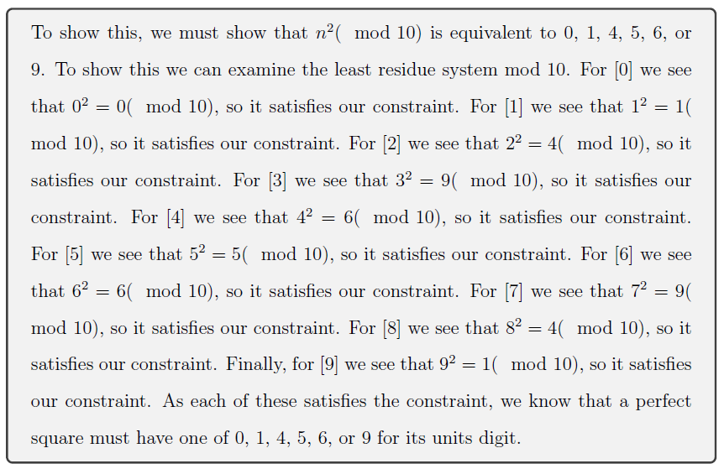

1. Show that any *n* consecutive integers form a complete residue system modulo *n*.

Suppose $a, a+1, a+2, ..., a+(n-1)$ are *n* consecutive integers. To show that they form a complete residue system modulo *n,* it is enough to show that no two are congruent modulo *n* since there are exactly *n* integers in the list. Suppose $a+i≡a+j (mod n).$ Then $i≡j (mod n),$ which is a contradiction since $\{0,1,..., n-1\}$ form a complete residue system modulo *n.*

1. Show that $1^{2}, 2^{2}, 3^{2}, ..., m^{2}$ is not a complete residue system modulo *m* if $m>2.$

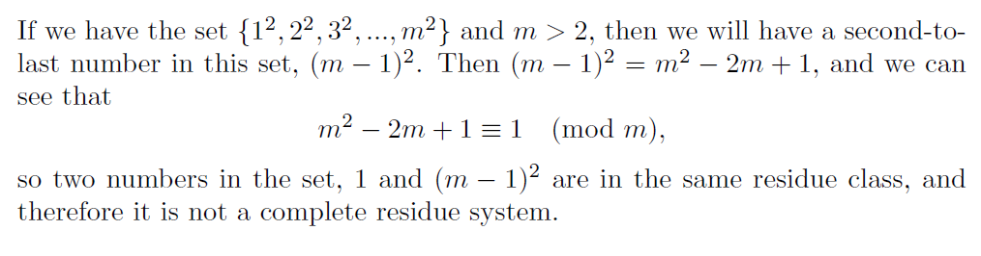

1. Prove that 17 does not divide $5n^{2}+15$ for any *n.*

* Every $n$ can be represented as $n=17k+r$ for $0≤r<17$.
* Thus, every perfect square can be represented as $n^{2}=17(17k^{2}+kr)+r^{2}$ for $0≤r<17$.
* So the possible residues of $n^{2}$ modulo 17 are exactly the squares of the possible residues of $n$ modulo 17.
* Squaring each entry of $\{0, 1, 2, 3, 4, 5, 6, 7, 8, 9, 10, 11, 12, 13, 14, 15, 16\}$ and reducing mod 17 yields $\{0, 1, 4, 9, 16, 8, 2, 15, 13, 13, 15, 2, 8, 16, 9, 4, 1\}$
* We only needed to check half of this list because the entries will repeat after the ninth entry for the reason presented at the end of problem 6. But I calculated all squares anyway.
* Removing repeated entries tells us that the possible residues of $n^{2}$ modulo 17 are $\{0, 1, 2, 4, 8, 9, 13, 15, 16\}$.
* Multiplying each of these entries by 5, adding 15, then reducing modulo 17 yields $\{15, 3, 8, 1, 4, 9, 12, 5, 10\}$.
* The fact that this list does not contain a 0 means that $5n^{2}+15$ is never congruent to 0 modulo 17. Thus 17 does not divide $5n^{2}+15$ for any $n.$

I'm going choose to solve this as a modular question

5n^2 +15 == 0 mod 17 5n^2 == 2 mod 17

5n^2 == 70 mod 17 n^2 == 14 mod 17

At this point we check if any of the x mod 17 number types give us a remainder of 14

If you go through and check we see

1, 4, 9, 16, 8, 2, 15, 13, 13, 15, 2, 8, 16, 9, 4, 1, 0